Loading the HTML & CSS File onto Github Repository

Step1: Logged into my github account

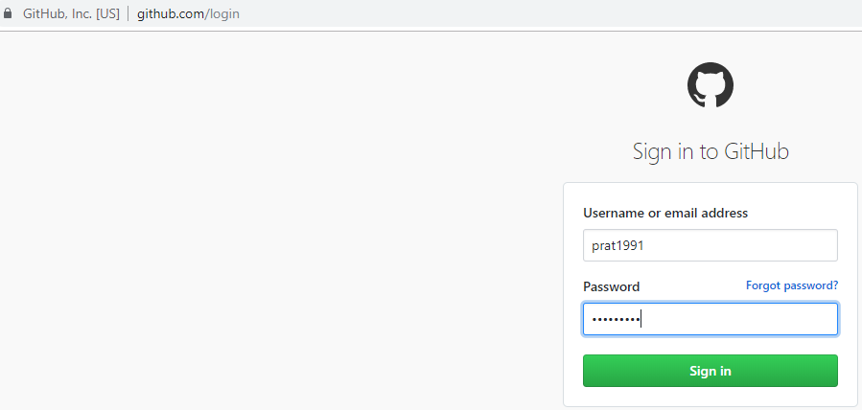

Step2: Created a public repository in github called “Prime-Academy-HTML-Challenge”

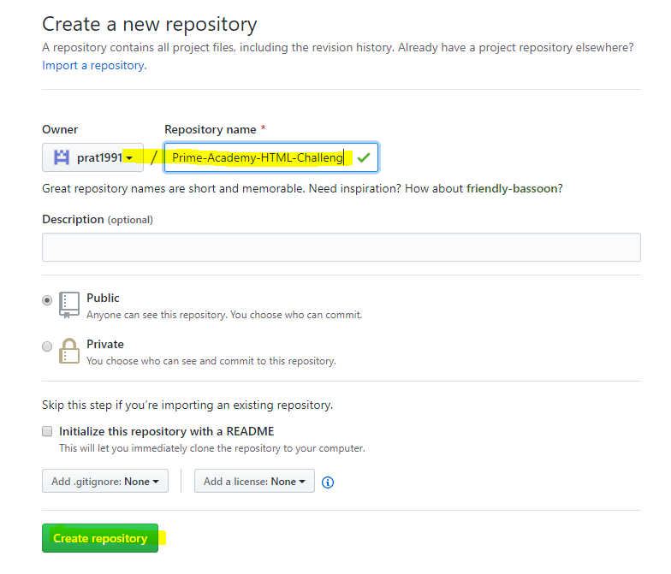

Step3: Uploaded my completed html and css files for the HTML Resume Assignment (See Attachments below)

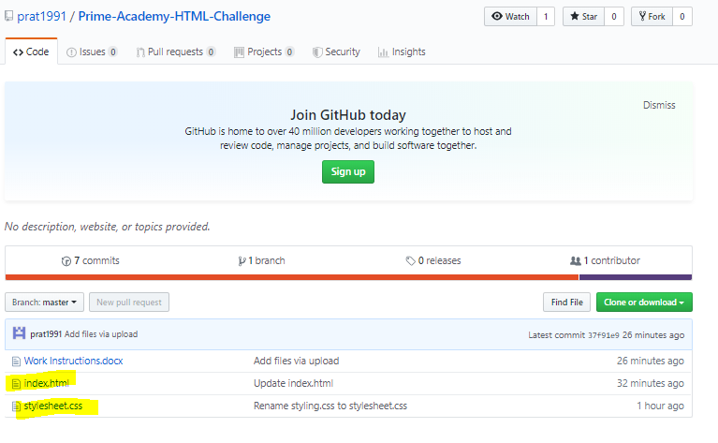

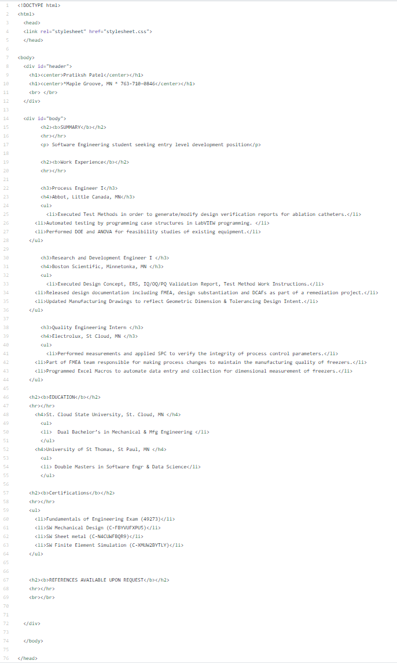

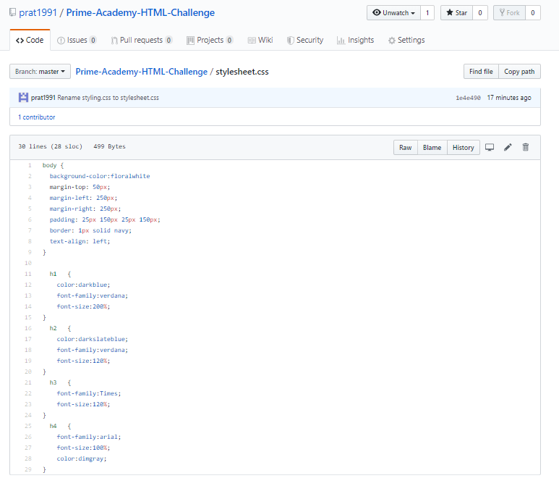

Hosting HTML Resume Challenge onto Github Pages

Step4: Clicked on Settings

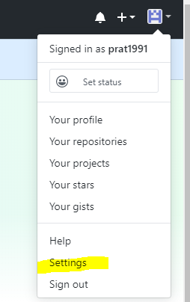

Step5: Selected Source as my master branch and clicked save

……Saving the Github Pages URL as <https://prat1991.github.io/Prime-Academy-HTML-Challenge/>

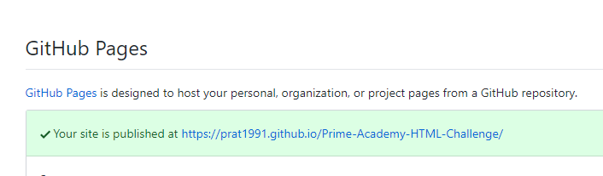

Step6: logging out of my github account

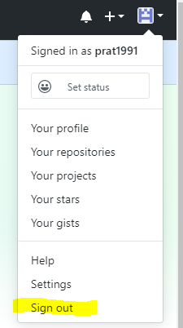

Step7: After logging out of my Github account; I copied and pasted the Github Pages URL from the step 6 <https://prat1991.github.io/Prime-Academy-HTML-Challenge/> into a web browser in order to see if my HTML Resume can be viewed by anyone on the internet. Verified that my HTML Resume is viewable to anyone on the internet.

